**Intel College Excellence Program   
Project Synopsis**

**“RFID -Based Access Control System using Arduino and GSM module”**

|  |  |  |  |
| --- | --- | --- | --- |
| **Team member’s detail** | | | |
| **S. No.** | **Participant Name** | **Mobile No.** | **Email ID** |
| 1 | Chintada Pradeep kumar swami | 6305707880 | ***Chintadapradeepkumarswami123@gmail.com*** |
| **Faculty(college) mentor detail** | | | |
| **S. No.** | **Mentor Name** | **Mobile No.** | **Email ID** |
| 1 | Dr. Shelej Khera | 9466731632 | ***shelej.22390@lpu.co.in*** |
| **College/University Name** | | | |
| ***Lovely Professional University*** | | | |

**BACKGROUND**

RFID (Radio-Frequency Identification) technology is commonly utilized in access control systems to manage entry to restricted areas or resources. It involves the use of RFID tags or cards, which contain unique identification information and communicate with RFID readers via radio waves. Arduino microcontrollers, on the other hand, are widely used in electronics projects for their versatility and ease of programming. They can process data from various sensors and devices, making them ideal for implementing access control logic. Integrating GSM (Global System for Mobile Communications) modules into an RFID-based access control system enhances its capabilities by enabling remote communication. GSM modules facilitate the transmission of data via cellular networks, allowing administrators to receive real-time notifications or alerts about access events, system status, or security breaches. This remote communication feature adds an extra layer of security and convenience to the access control system, as administrators can monitor and manage it from anywhere with cellular coverage.

**PROBLEM IDENTIFICATION**

In the integration of RFID technology with Arduino microcontrollers and GSM modules for an access control system, several potential challenges may arise. Signal interference and range limitations could impede the reliable detection of RFID tags, particularly in environments with high electronic device density. Security vulnerabilities, such as unauthorized access due to tag cloning or spoofing, pose significant risks if encryption methods or authentication protocols are insufficient. Additionally, ensuring the reliability and durability of components like RFID readers, tags, and GSM modules is crucial to maintaining system performance over time. Scalability challenges may emerge when expanding the system to accommodate more users or access points, requiring careful management of databases and compatibility with existing infrastructure. Efficient power management is essential, especially in battery-operated setups, to sustain uninterrupted communication via GSM modules. Moreover, integration complexity with other security systems or databases may necessitate thorough customization and interoperability testing. User training and support are vital to ensure proficient use of the system's features and address any operational issues promptly. Finally, adherence to regulatory standards for data privacy, security, and telecommunications is essential to avoid legal and operational complications. Addressing these challenges proactively during system design and implementation is critical to ensuring the effectiveness, reliability, and security of the RFID-based access control system using Arduino and GSM module.

**PROPOSED SOLUTION**

To address the identified challenges in the RFID-Based Access Control System using Arduino and GSM module, several solutions can be proposed:

1. Signal Interference Mitigation: Implement shielding techniques or use specialized antennas to minimize signal interference from nearby electronic devices, ensuring reliable RFID tag detection.

2. Enhanced Security Measures: Introduce stronger encryption methods and authentication protocols to prevent unauthorized access and mitigate the risk of tag cloning or spoofing.

3. Component Reliability Improvements: Select high-quality, durable components for RFID readers, tags, Arduino boards, and GSM modules to enhance reliability and longevity, minimizing system downtime.

4. Scalability Planning: Design the system with scalability in mind, employing modular architecture and efficient database management techniques to facilitate seamless expansion as the number of users or access points grows.

5. Optimized Power Management: Implement power-saving features and efficient communication protocols to prolong battery life in GSM modules, ensuring continuous operation and minimizing maintenance requirements.

6. Simplified Integration Interfaces: Develop standardized interfaces and protocols for seamless integration with other security systems or databases, streamlining the integration process and minimizing customization efforts.

7. Comprehensive User Training and Support: Provide thorough user training programs and accessible technical support channels to empower users with the knowledge and assistance needed to effectively use the system and troubleshoot any issues.

8. Regulatory Compliance Assurance: Conduct thorough compliance assessments and ensure adherence to relevant regulatory standards for data privacy, security, and telecommunications, mitigating legal and operational risks.

**COMPONENTS REQUIRED**

If we want to implement the RFID-Based Access Control System using Arduino and DHT 11 these are the components required:

1. Arduino board
2. RFID reader module (e.g., MFRC522)
3. RFID tags/cards
4. LCD display
5. Buzzer and LED’s
6. GSM module
7. Breadboard
8. Jumper wires (Male to Male & Female to Male)

**Flow Charts & DESCRIPTION**

The RFID-Based Access Control System using Arduino and GSM module combines RFID technology, Arduino microcontrollers, and GSM communication capabilities to create a comprehensive access control solution. In this system, RFID tags or cards are used for user identification, while Arduino microcontrollers manage the authentication process and control access to restricted areas or resources. The addition of GSM modules enables remote communication, allowing administrators to receive real-time notifications or alerts about access events, system status, or security breaches via SMS or calls. This remote monitoring and management feature enhances security and convenience, as administrators can monitor and manage the access control system from anywhere with cellular coverage. Overall, the integration of RFID technology, Arduino microcontrollers, and GSM modules offers a versatile and efficient solution for access control applications, ensuring reliable authentication and effective communication for enhanced security and convenience.

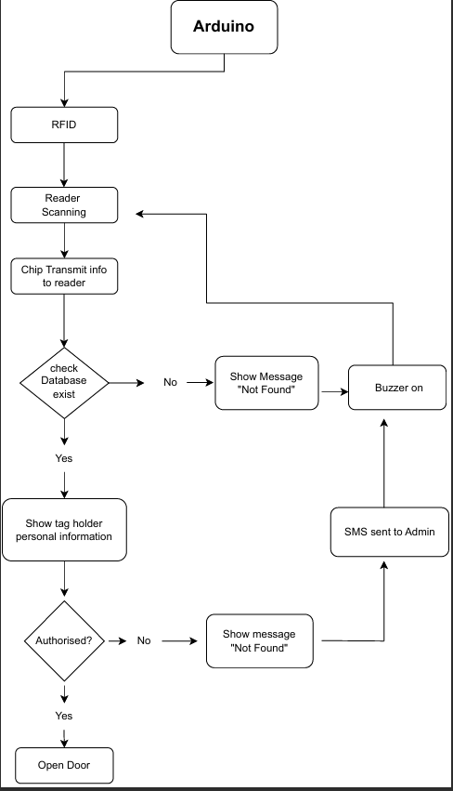

**CODE**

**#include <SPI.h>**

**#include <MFRC522.h>**

**#include <SoftwareSerial.h>**

**SoftwareSerial Sim(5,6);//GSM txd and rxd pins**

**#define SS_PIN 10**

**#define RST_PIN 9**

**#define ACCESS_DELAY 2000**

**#define DENIED_DELAY 1000**

**#define buzzer A5**

**MFRC522 mfrc522(SS_PIN, RST_PIN); // Create MFRC522 instance.**

**void setup()**

**{**

**Serial.begin(9600); // Initiate a serial communication**

**Sim.begin(9600);**

**Sim.println("AT");**

**delay(1000);**

**Sim.println("AT+CMGF=1"); // Set message format to text mode**

**delay(1000);**

**SPI.begin(); // Initiate SPI bus**

**mfrc522.PCD_Init(); // Initiate MFRC522**

**pinMode(buzzer,OUTPUT);**

**Serial.println("Put your card to the reader...");**

**Serial.println();**

**delay(500);**

**}**

**void loop()**

**{**

**int b=0; // Look for new cards**

**if ( ! mfrc522.PICC_IsNewCardPresent())**

**{**

**return;**

**}**

**// Select one of the cards**

**if ( ! mfrc522.PICC_ReadCardSerial())**

**{**

**return;**

**}**

**//Show UID on serial monitor**

**Serial.print("UID tag :");**

**String content= "";**

**byte letter;**

**for (byte i = 0; i < mfrc522.uid.size; i++)**

**{**

**Serial.print(mfrc522.uid.uidByte[i] < 0x10 ? " 0" : " ");**

**Serial.print(mfrc522.uid.uidByte[i], HEX);**

**content.concat(String(mfrc522.uid.uidByte[i] < 0x10 ? " 0" : " "));**

**content.concat(String(mfrc522.uid.uidByte[i], HEX));**

**}**

**Serial.println();**

**Serial.print("Message : ");**

**content.toUpperCase();**

**if (content.substring(1) == "99 8D 5D 6D") //change here the UID of the card/cards that you want to give access**

**{**

**Serial.println("Authorized access");**

**Serial.println();**

**delay(500);**

**}**

**int x= bool(content.substring(1) != "99 8D 5D 6D");**

**if(x){**

**Serial.println("Access Denied");**

**digitalWrite(buzzer,HIGH);**

**delay(5000);**

**digitalWrite(buzzer,LOW);**

**delay(1000);**

**}**

**if(x){**

**Serial.println("Sending messege....");**

**Sim.print("AT+CMGS=\"+919705490493\"\r"); // change to the phone number you using**

**delay(1000);//delay of one second**

**Sim.println("Hey Sai\nAlert! Somebody entered");**

**Sim.write(26);//the content of the message**

**}**

**}**

**OUTPUT & HARDWARE CIRCUIT CONNECTION**

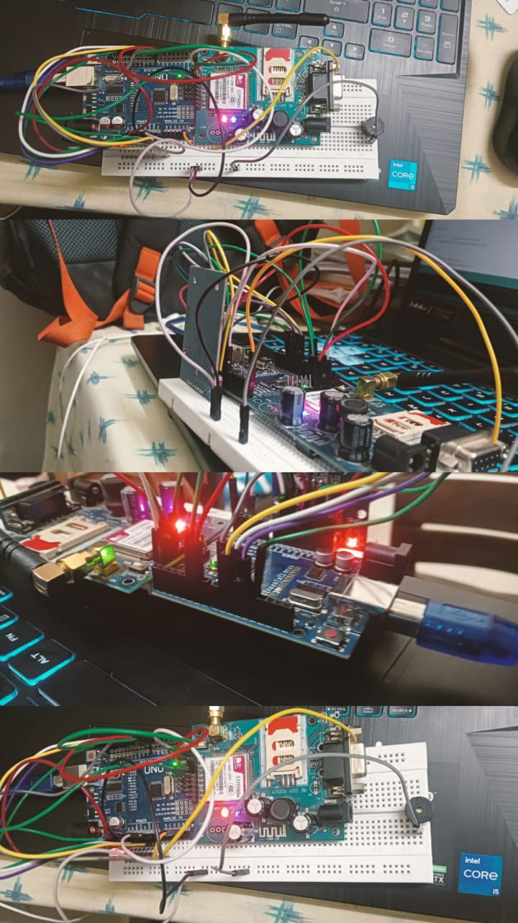

**Software Simulation**

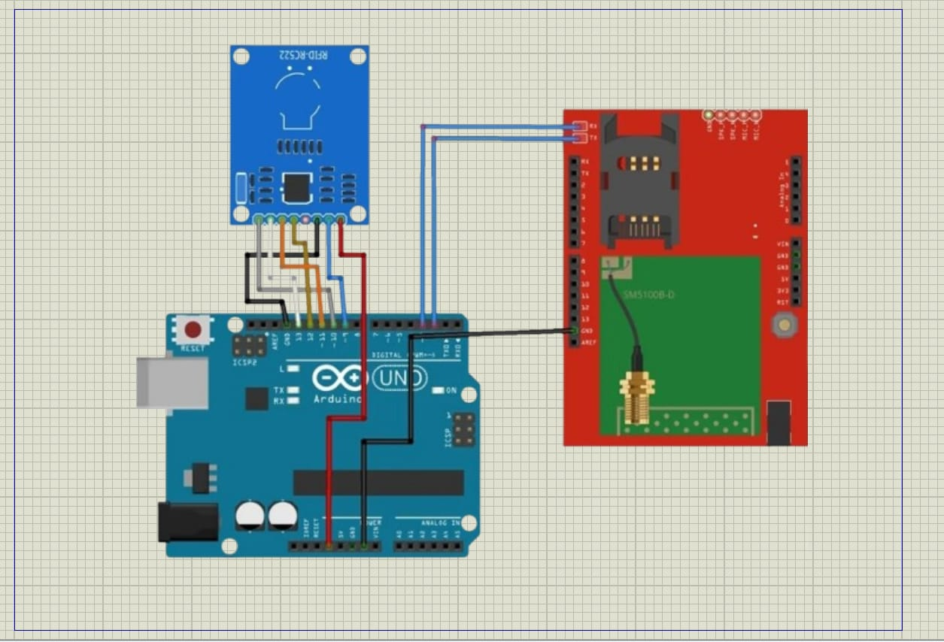

**FUTURE SCOPE**

The future scope for RFID-Based Access Control Systems using Arduino and GSM modules is promising, with several avenues for development and enhancement:

1. Enhanced Security Features: Future iterations of the system could incorporate advanced encryption techniques, biometric authentication, or multi-factor authentication methods to further strengthen security and prevent unauthorized access.

2. Integration with IoT and Cloud Services: Integration with Internet of Things (IoT) devices and cloud-based services could enable advanced features such as remote monitoring, real-time data analytics, and seamless integration with other smart building systems for enhanced security and operational efficiency.

3. AI and Machine Learning Integration: Incorporating artificial intelligence (AI) and machine learning algorithms can enable the system to learn from access patterns, detect anomalies, and adapt access control rules dynamically to improve efficiency and responsiveness to evolving security threats.

4. Enhanced Remote Management: The system could offer more sophisticated remote management capabilities, allowing administrators to remotely configure access permissions, update firmware, and troubleshoot issues via GSM communication.

5. Energy Efficiency: Research and development efforts can focus on designing energy-efficient solutions, including low-power components and optimized communication protocols, to reduce the system's environmental footprint and operational costs, especially in battery-powered setups.

6. Scalability and Interoperability: Future systems could prioritize scalability and interoperability, allowing seamless integration with existing access control infrastructure and accommodating the needs of growing organizations or facilities.

7. User Experience Improvements: Enhancing user interfaces, introducing mobile applications for remote access control, and implementing personalized access settings can improve the overall user experience and convenience.

8. Blockchain Integration: Leveraging blockchain technology for secure and tamper-proof storage of access logs and user credentials can provide an additional layer of security and transparency to the system.

9. Adaptation to Emerging Technologies: The system should remain adaptable to emerging technologies and standards in RFID, IoT, and telecommunications to stay relevant and effective in addressing evolving security challenges.

**CONCLUSION**

In conclusion, the RFID-Based Access Control System using Arduino and GSM module offers a robust solution for managing access to restricted areas or resources. By integrating RFID technology with Arduino microcontrollers and GSM communication capabilities, this system provides reliable authentication, efficient access control, and remote monitoring functionalities. Its versatility, scalability, and potential for future enhancements make it a valuable asset for organizations seeking to enhance their security infrastructure. With the ability to address evolving security challenges and meet the diverse needs of modern security environments, the RFID-Based Access Control System using Arduino and GSM module stands as a reliable and effective solution for access control applications.

**REFERENCES**

*<* https://github.com/LikhithChava/IOT_Smart_Irrigation_System*>*

**THANK YOU TO FICE**